HUBS Workshop: Understanding and implementing inclusive learning and teaching in bioscience education

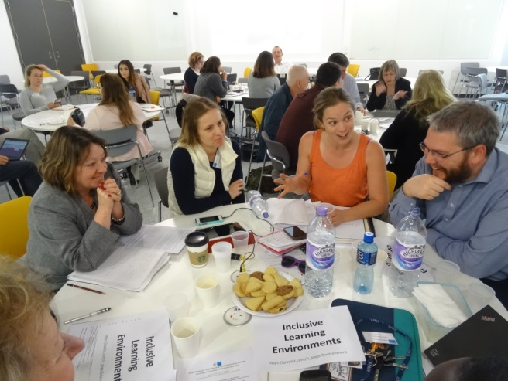
Nigel Page and Lucy Jones hosted the HUBS workshop on ‘Understanding and implementing inclusive learning and teaching in bioscience education’ on Monday 3rd April 2017 at Kingston University. We welcomed not only staff and students from Kingston University but academics from external institutions, local school teachers and college lecturers. We kicked off by getting delegates to think about the general issues regarding equality, diversity and inclusion and the challenges faced in higher education. We looked at ‘Equality and you’, ‘what the current metrics are telling us’ and ‘why there is an attainment gap’. We then ran some activities to help identify and overcome some of the barriers faced. This was followed by a range of short joint presentations given by staff and students, where we exemplified inclusion throughout the student journey; from the challenges faced in transition, to developing a positive inclusive ethos, to motivators and aspirations in employability. We also looked at the technologies available to help with our learning and teaching approaches, and how co-curricular activities and getting students directly involved as curriculum consultants can help implement an inclusive learning environment. We rounded the afternoon off with reviewing the lessons to be learnt and the way forwards for transformative change that could be used to develop guidelines of good practice in the biosciences.

