BALLOT PAPER

Which of the following food types most deserves to be saved?
Vote for One Candidate Only
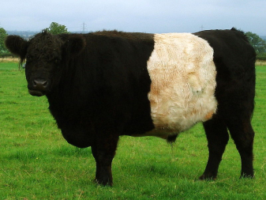
Mark Your Vote with an X

Beef: This is the most carbon intensive, producing 34.6kg CO₂e/kg of meat compared to chicken which produces 4.57 kg CO₂ e / kg of meat.
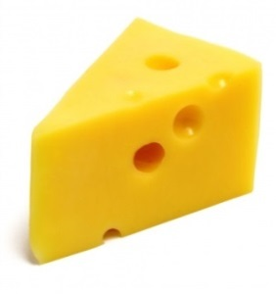

Cheese: The life cycle greenhouse gas emissions of a kilogram of hard cheese is about 8.8kg CO₂, which is similar to driving a car 20 miles.

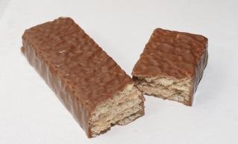

Chocolate: The ingredients to make a chocolate bar can travel from four continents and over 30,000 miles.

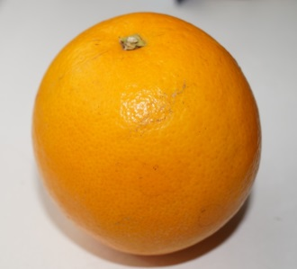

Oranges: Most UK oranges travel around 800 miles from Spain compared to most UK bananas travelling 4,600 miles from the Caribbean.
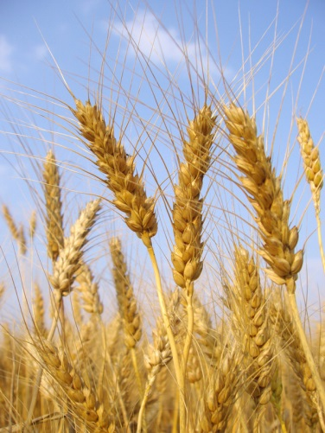

Wheat: Winter wheat has a lower carbon footprint than beef and cheese – it’s similar to driving about 2,700km in a car.
BALLOT PAPER

Which of the following food types most deserves to be saved?
Vote for One Candidate Only
Mark Your Vote with an X

Beef: This is the most carbon intensive, producing 34.6kg CO₂e/kg of meat compared to chicken which produces 4.57 kg CO₂ e / kg of meat.

Cheese: The life cycle greenhouse gas emissions of a kilogram of hard cheese is about 8.8kg CO₂, which is similar to driving a car 20 miles.

Chocolate: The ingredients to make a chocolate bar can travel from four continents and over 30,000 miles.

Oranges: Most UK oranges travel around 800 miles from Spain compared to most UK bananas travelling 4,600 miles from the Caribbean.

Wheat: Winter wheat has a lower carbon footprint than beef and cheese – it’s similar to driving about 2,700km in a car.

