Gopher Science Lab background information:
The Royal Society of Biology’s Gopher Science Lab enables secondary schools to host a hands-on science event as part of a transition or extra-curricular activity for local primary schools. During the Gopher Science Lab day secondary science students teach primary students how to perform simple science activities. To enable sixth form students to teach visiting primary students, teachers first need to pre-train their sixth form students in the use of the Gopher Science Lab activities (if a school does not have a sixth form younger students may like to get involved).
The activities have been suitably prepared, tested and trialled as part of Gopher Science Lab in Wales throughout 2014 and all activities have been approved by CLEAPPS. The hands-on science activities are available as a free teacher resource booklet, which can be downloaded from the Gopher Science Lab webpage (http://www.rsb.org.uk/gophersciencelabs).
Schools wanting to find new schools to work with through a Gopher Science Lab event may use the online search feature on the Gopher Science Lab webpage to find schools which have registered their interest in taking part. To access the search you are first taken to the Royal Society of Biology’s free user registration page (mySociety) where you need to register your email address to gain a password, which allows teachers to register their school. Please note your user name is the email address you register and your password will be sent to that email address for use later on.
After you have gained a password to use with your email address (username) you can register your school and look for a school to link with in a two-step process. First you give details of your school; secondly you search for a school near you. Please note if you don’t find a school to link with when you first search the database it might be that there are not at present any schools registered in your area. If you need help please email Amanda Hardy the Royal Society of Biology’s schools and colleges officer.
Step one:
Register your school.
You reach a page shown in figure 1 overleaf.
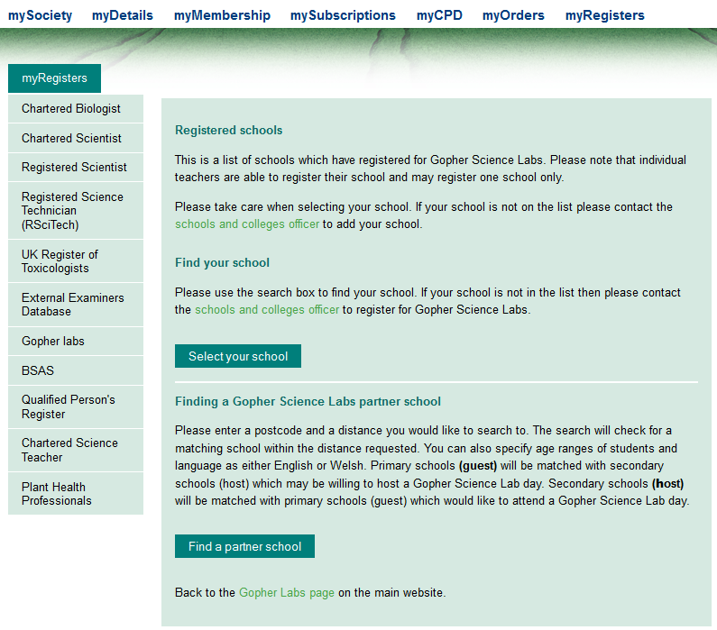

Figure 1 Gopher Science Lab school registration and search page.

Registered schools
This is a list of schools able to register for Gopher Science Lab. Please note that individual teachers are able to register their school and may register one school only.
Please take care when selecting your school. If your school is not on the list please contact Amanda Hardy the Royal Society of Biology’s schools and colleges officer to add your school, you will need to send your school’s name, full postal address and exam centre number if it is a secondary school or if it is a primary school please make this clear in your email. Once your school has been added to the list you will receive an email letting you know and you may continue to follow the instructions which follow:

Find your school
Please use the search box to find your school. This is shown in Figure 2.
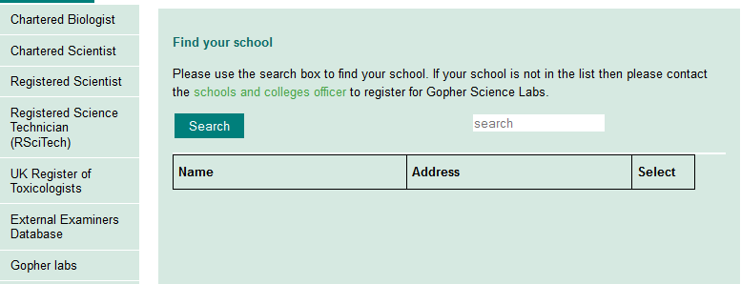

Figure 2 Find your school screen.

Once you have found your school you may register for Gopher Science Lab by clicking select. Please note you need to add a contact email address to allow other schools to contact you via the system’s messaging system.
Step two:

Finding a Gopher Science Lab partner school
You reach a screen shown in Figure 3. Please enter a postcode and a distance you would like to search to. The search will check for a matching school within the distance requested. You can also specify age ranges of students and language as either English or Welsh. Primary schools (guest) will be matched with secondary schools (host) which may be willing to host a Gopher Science Lab day. Secondary schools (host) will be matched with primary schools (guest) which would like to attend a Gopher Science Lab day.
Once you have found a school to link with you may send them a message. Please note in order to share your email address with the other school you need to include this in the text of your message as the system does not automatically share your email address.

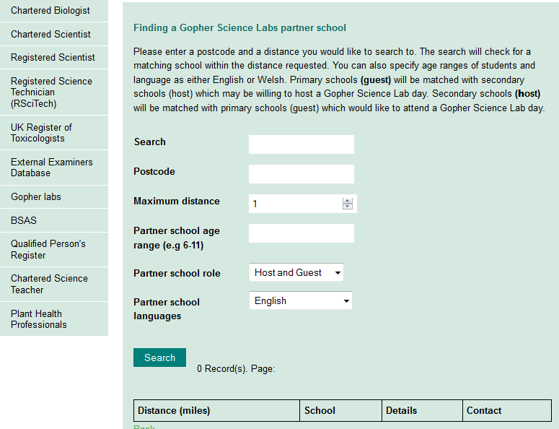

Figure 3 Finding a Gopher Science Lab partner school screen.

