Balloon flies/ Dagger Flies (Empididae)

What are balloon flies?
Balloon flies are one group of the family of true flies called Empididae. There are a number of species of balloon-flies, that differ in shape and size. All balloon flies share a surprising mating behaviour… read on to find out more!

Where do they live? - Different species of balloon-fly are found worldwide in a range of habitats.
What do they look like? - Balloon flies are small to medium sized flies and usually have long dark-coloured bodies. The legs are slender and often adapted for grasping other insects. The proboscis is often long and pointed so some species are known as ‘Dagger flies’.
What do they eat? This group of flies mainly eat small insects, and occasionally nectar. Larvae often feed on decaying organic matter in the soil.

Balloon flies give ‘balloons’ as gifts!
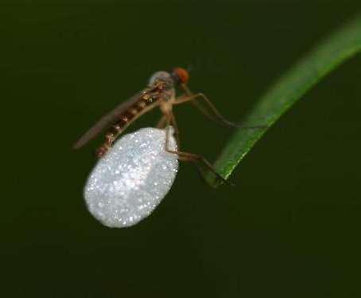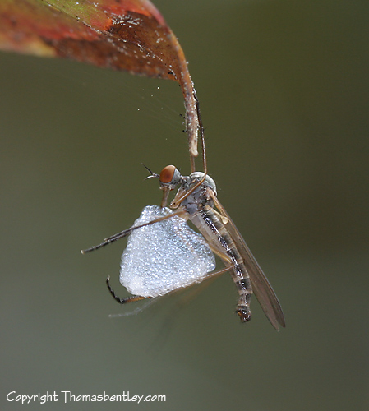
Balloon flies offer ‘nuptial gifts’ to attract mates. Male balloon-flies catch an insect, kill it, wrap it a ball of silk, the ‘balloon’, and offer it to females in mating swarms. Swarms are large groups of insects. When in the mating swarms male balloon-flies fly up and down in a sort of dance. Females seem to choose the male with the most enticing balloon offering. Sometimes a male may offer just an empty ball of silk. If there is something inside the balloon the female chooses she may eat it.
Different species swarm at different times of day. Some may swarm during the whole day, others maybe only for an hour at dusk, etc. The location of the swarm is determined by a ‘marker’ such as a branch or along a slope.

More fun balloon-fly facts:
- The names of the body parts are; head, thorax and abdomen.
- Their life cycle involves three stages: Eggs, larvae and then adult.
- Adults have six legs, larvae have none.
- Larvae of different species can be found in the soil, in aquatic habitats, in roots, in dung and even in birds nests!
- They have compound eyes – made up of lots of tiny individual lens and receptors to process what they see.
- Other similar species offer different nuptial gifts in mating swarms such as dead insects.
- Balloon-flies can also be called ‘dance-flies’ because they dance in mating swarms. A wide range of fly species ‘dance’ in swarms as part of their mating ritual but not all offer nuptial gifts.

Scientists are trying to find out more about balloon-flies….
In several balloon fly species, males offer and females accept "empty gifts" with no nutritional value. Males within a mating swarm also have different-sized balloons and compete to attract the most females. A recent study of one species found larger males with intermediate-size balloons have greatest mating success. The scientists think this can be explained by a trade-off between long-range attraction of females using large balloons and close-range attraction of females via improved flying efficiency associated with smaller balloons.

Scientific Classification

Kingdom: | Animalia
Phylum: | Arthropoda
Class: | Insecta
Order: | Diptera
Suborder: | Brachycera
Infraorder: | Asilomorpha
Superfamily: | Empidoidea
Family: | Empididae

