Circadian rhythms
Activity 1: What is your bird body clock? (all ages although child version could have fewer questions)
People answer the quiz (see below) and add up their score on our giant totaliser to find out what bird they are. They would get a sticker with a photo of whatever bird they turn out to be on it. Volunteer would explain to participant how our circadian rhythm is part of our genetic make-up and the involvement of melatonin and the pineal gland. They would also explain how different birds are active at different times of the day and discuss adaptations for being active at night.
Intro to the quiz:
Humans are diurnal – i.e. active in daylight hours and asleep when it is dark.
But there are differences between people meaning some are more like early-morning birds so wake up very early and get tired early in the evening and some wake up later and don’t get tired until later.
These are differences in their body clocks, special bits of their brain that they are born with and can’t easily change. Sleep researchers are very interested in what makes people different in this way and use a special quiz to find out what kind of body clock people have.
There are five types and you can find out what type of body clock you have and which bird your body clock is most similar to! You will get a sticker at the end showing which type of bird you are most like.
Discussion points:
Do you know that humans and birds both have special chemical messages called hormones that tell our bodies when to wake up and when to go to sleep?
Have you heard of hormones? Do you think you could explain what a hormone does?
Melatonin is a hormone released by a special bit of our brain called the pineal gland – it is right in the middle of our brain and it shaped like a pine cone. The pineal gland releases more melatonin when it is dark. The amount of light hitting our retina in our eyes acts like a message and this tells the pineal gland to release more or less melatonin. The melatonin acts like a messenger to other bits of our brain and eyes and the more melatonin they receive, the more sleepy we feel.
Cortisol is made and released by our adrenal glands – these are glands on top of your kidneys. Cortisol levels in our bodies increase during the last bit of the night. It is highest first thing in the morning and lowest in the first half of the night. Cortisol does lots of important things in the body including controlling how we get energy from our foods and how our lungs and heart work.
Why do you think some birds are active at night and others in the day?
What are the differences between these kinds of birds?
Recent research indicates smaller birds wake up and start singing earlier in the morning that larger birds- the scientists think it is because they have smaller bodies so can’t store as much food).
Props: brain model, bird skulls
This a reduced version of the Diurnal Preference Questionnaire used by sleep researchers. Courtesy of the University of Surrey
ADULTS
- Read each question carefully before answering – and answer honestly
- Answer each question independently of the others
- Don’t go back and check your answers
- Keep a tally of the points next to your preferred answer to reveal your sleep score
1. Considering only your own ‘feeling best’ rhythm, at what time would you get up if you were entirely free to plan your day?
05:00-06:30am (5 points)
06:30-07:45am (4 points)
07:45-09:45am (3 points)
09:45-11:00am (2 points)
11:00-12:00am (1 point)
2. During the first half-hour after having woken in the morning, how tired do you feel?
Very tired (1 point)
Fairly tired (2 points)
Fairly refreshed (3 points)
Very refreshed (4 points)
3. At what time in the evening do you feel tired and, as a result, in need of sleep?
08:00-09:00pm (5 points)
09:00-10:15pm (4 points)
10:15pm-12:45am (3 points)
12:45-02:00am (2 points)
02:00-03:00am (1 point)
4. At what time of day do you think that you reach your ‘feeling best’ peak?
05:00-07:00am (5 points)
08:00-09:00am (4 points)
10:00am-04:00pm (3 points)
05:00pm-09:00pm (2 points)
10:00pm-04:00am (1 points)
5. You may have heard about ‘morning’ and ‘evening’ types of people. Which one of these types do you consider yourself to be?
Definitely a ‘morning’ type (6 points)
Rather more a ‘morning’ than an ‘evening’ type (4 points)
Rather more an ‘evening’ than a ‘morning’ type (2 points)
Definitely an ‘evening’ type (0 points)

Your score
22-25 points = definitely morning type - LARK 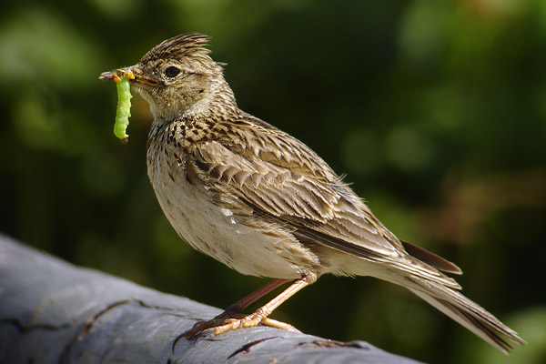
You are the ultimate early bird, but you pay for it in the evening when you nod off early.
18-21 points = moderately morning type - CHAFFINCH 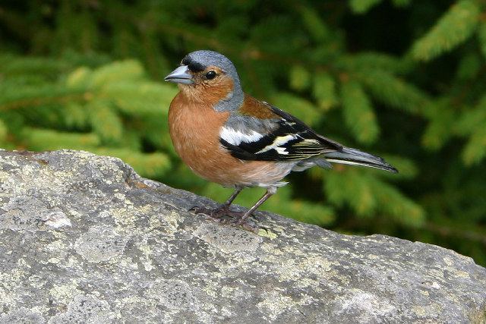
Mornings are your thing. You're out of bed early and greet the new day with a smile.
12-17 points = neither type
Neither a morning lark or a night owl, you're somewhere in the middle. The best of both worlds. – PARTICIPANT CAN CHOOSE TWO ANY TWO STICKERS!
8-11 points = moderately evening type - NIGHT-JAR 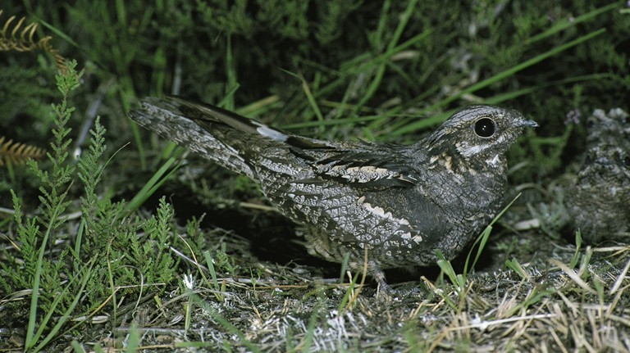
You're no stranger to burning the midnight oil and love a late night. But mornings are a struggle.
4-7 points = definitely evening type – LONG-EARED OWL 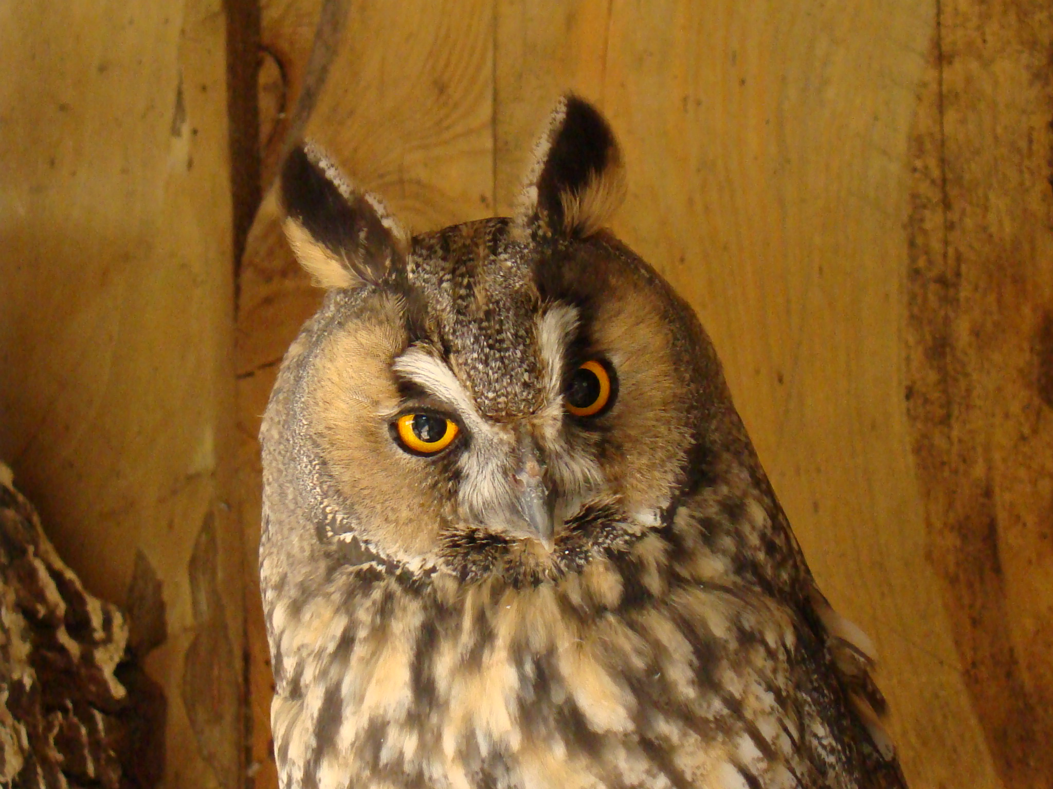
Early starts fill you with dread, but no one can power through the night like you.
Variation for children
If you could get up at any time of the day when would that be?
- 05:00-07:45am
- 07:45am onwards
At what time of day do feel at your ‘most awake’? (i.e. when you have the most amount of energy).
- 05:00- midday
- Midday or later
Those who answer a) to both are a lark
Those who answer one a) and one b) are a chaffinch
Those who answer b) to both are a night owl

Source: http://www.surrey.ac.uk/features/surrey-sleep-quiz-%E2%80%93-are-you-lark-or-owl
http://www.livescience.com/16334-night-owls-early-birds-sleep-cycles.html
Activity 2: Make your own body clock (younger children)
Each child makes their ‘body clock’ to take home on a string round their neck (basically a circle of cardboard worn like a medallion!). They are asked what time they would like to wake up if they could choose any time and what time they would like to go to sleep. Children also ask when they feel most hungry. They colour in their clocks (example clocks will show the 24 hour period coloured in two colours to indicate awake time and asleep time), add sticky dot stickers in three different colours to indicate different hormones and draw a picture of food at the time they are most hungry.
Clock cut-out resource and participant instructions -
SEE ATTACHED PUBLISHER FILE

Discussion points:
- How do our bodies know it is time to sleep and time to wake up? (discuss effect of daylight and darkness
- Why do you think we are sleepy when it is dark and active when it is light? (discuss advantages of being awake in the day)
- Are animals the same as us? Do they all sleep at night? Can you think of some animals who are active when it is dark? (discuss nocturnal and diurnal animals and their differences, advantages of being active at night – RVC props would work well here too)
- With older children: Could introduce idea of our internal clock (some people are larks some are owls etc.) and /or introduce the idea of hormones and their role in regulating our body clocks (chemical messengers that are produced by our bodies that tell our organs what to do when; e.g. melatonin is produced by the pineal gland and is what makes us sleepy – levels of melatonin build up in the evening)

Activity 3: Nocturnal, diurnal and crepuscular animals
Simple matching game. Specimens/ toys/ pictures to represent each animal listed below. Participants have to put the animals into the correct labelled tray. Laminated sheets explaining adaptations and advantages /disadvantages related to being active at day/ night. Props will be used to illustrate these
- o Domestic dog - diurnal
- o Domestic cat – crepuscular/ nocturnal
- o Human - diurnal
- o Squirrel- diurnal
- o Badger- nocturnal
- o Green iguana - diurnal
- o Beaver - crepuscular
- o Donkey - diurnal
- o Stag beetle - diurnal
- o Butterfly - diurnal
- o Hedgehog - nocturnal
- o Pig - diurnal
- o Monkey - diurnal
- o Fruit bat - diurnal
- o Vampire bat - nocturnal
- o Owl - nocturnal
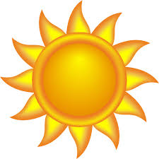
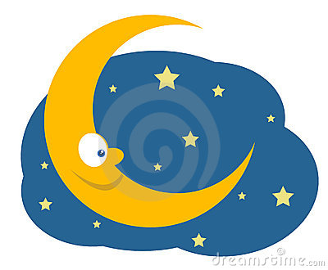
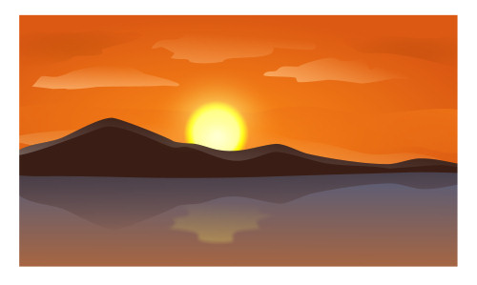
Diurnal – awake and active in daytime
Nocturnal – awake and active at night-time
Crepuscular – awake and active at twilight (dawn and dusk)
Tray/ box 1
Tray/ box 2
Tray/ box 3

There will (hopefully!) be accompanying fact cards for people to read (and possibly take away) about each animal and its circadian clock and behaviours/ adaptations related to this.
Activity 4: Sleep quiz – true or false
Large cards with a different sleep fact or myth with a picture and true/ false written on the back.
1. Dolphins do not sleep. False. They sleep with half their brain at a time.
2. Cows sleep and dream standing up. True.
3. It is impossible to sleep with your eyes open. False. People who sleepwalk and babies often have their eyes open or partially open when asleep.
4. Fish close their eyes to sleep. False. Fish have no eyelids!
5. Birds often sleep standing on one leg. True - a sign of illness in birds is when they sleep on two legs
6. People need less sleep as they get older. False - As we get older, we don't need less sleep, but we often get less sleep. That's because our ability to sleep for long periods of time and to get into the deep restful stages of sleep decreases with age. Older people have more fragile sleep and are more easily disturbed by light, noise, and pain. They also may have medical conditions that contribute to sleep problems. Going to bed at the same time every night and getting up at the same time every morning, getting exposure to natural outdoor light during the day, and sleeping in a cool, dark, quiet place at night may help.
7. Lions sleep for up to 20 hours a day. True
8. Sleep can be divided into different stages. True. Sleep can be divided into many stages including REM (rapid eye movement) and non-REM sleep.
Courtesy of British Council
Accompanying props: fish specimen, flamingo bone, bird skeleton, any other relevant specimens to show people.
There will be some animal stickers/ sweets to give to participants.

Activity 5: Hormone bucket game
Game for children to help explain the role of hormones in regulating our body clocks. Timed challenge that introduces melatonin, cortisol and grehlin and where these are released and active in the body.
http://www.nigms.nih.gov/Education/Pages/Factsheet_CircadianRhythms.aspx
This is a team game, where participants are transported to inside the human body and the goal is to control hormone levels in the body involved in waking up, eating and sleeping. The person leading the activity will walk them through it and then if the participants want to, they can then go for a timed run through
Each participant represents a different hormone secreting organ: the kidney, the Stomach, and the brain (Pineal gland). This will be represented by a model organ attached to an adjustable head band. Each participant will also have a number of coloured balls. These will represent the hormones Cortisol, Melatonin and Ghrelin and will be colour-coded / labelled.
Participants are lined up to represent the rough orientation of the organs in the body, e.g brain at one end and kidneys at the other. A human body will be marked out on a sheet on the floor and participants stand in the right place according to the organ they are representing.
The person leading the game has three buckets that they collect the hormones in, each in the same colour as the coloured ball they are representing. The idea is that the hormones must reach a certain level in the bucket (number of balls tbc), for each stage of the daily cycle.
Waking up
The game starts with the body asleep. This is represented by everyone sitting down. To wake up, participants must raise their level of Cortisol. The kidney does this by throwing the cortisol into the corresponding bucket several feet away. Only when they have managed to get sufficient hormone in the bucket will the body wake up. At this point everyone jumps to their feet.
Getting Hungry
The body needs food to fuel it, but we won’t eat until we are hungry. The Stomach must produce the hormone, Ghrelin, to promote appetite, uptake of food and storage of fat. This is done by the person representing the Stomach successfully filling the Ghrelin bucket in the same way as with Cortisol.
Getting full
The reward for successfully getting hungry is food. Each participant will be given an empty transparent tube labelled ‘leptin level’ (see picture below) and the facilitator will give them balls in a Tupperware container labelled ‘lunch’ to represent food to ‘eat’ – they will try and get the balls into the tube until it is full the fastest. Facilitator explains that leptin is produced by the fat cells when we eat, to signify we are full.
Going to sleep
The last step of the day is to tell the body to go to sleep. This is done by the production of Melatonin by the brain (pineal gland), which makes us feel tired. The participant representing the brain must successfully raise the level of Melatonin by filling up the corresponding bucket in the same way as with the cortisol and ghrelin. Once they do the body falls asleep, represented by all participants sitting back down again.
Repeat? (optional)
Now that the participants have completed the process once, with the help of the person running the game, they may want to try it again, but being timed. To see how quickly they can get through the day. We can then keep these scores on a leaderboard.
