Teaching Excellence Framework: Subject-level pilot specification
This summary is based on the Department of Education’s proposals for the first year of subject-level pilots, released on 20 July 2017.
- The design of the subject-level Teaching Excellence Framework (TEF) is based on the design of TEF Year 2 and will cover all undergraduate provision and all modes of delivery.
- Any changes to the framework following the lessons learned exercise looking at TEF Year 2 will be reflected in Year 3 subject-level pilots
- HEFCE will select 30-40 providers from across the UK Higher Education sector to take part. Participants will work with HEFCE and the Department for Education (DfE) to evolve the design of subject-level TEF throughout the pilots
- The pilots will run from Autumn 2017 to Spring 2018 but the assessments will not interact with the provider-level exercise.
- No ratings identifying individual providers will be published. The DfE will share findings from the pilots and evaluation after the Year 3 subject-level pilots end and before the Year 4 pilots begin.
- The second level of the new Common Aggregation Hierarchy will be used to define subjects. This has 35 subjects and the same set of 10 TEF criteria that were used in TEF Year 2 will be used across these subjects
Two models will be piloted:
- Model A: a ‘by exception’ model giving a provider-level rating and giving subjects the same rating as the provider where metrics performance is similar, with fuller assessments (and potentially different ratings) where metrics performance differ. Estimated that 39% of subjects across providers participating in the pilots will be assessed.
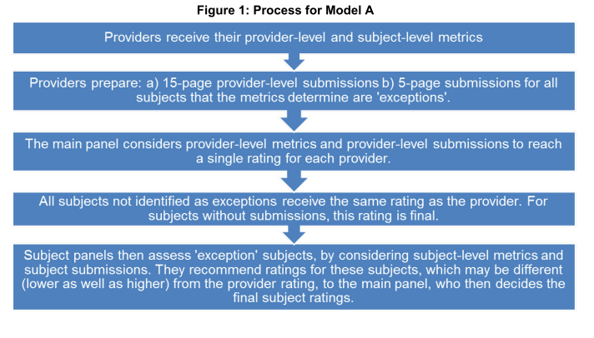
- Model B: a ‘bottom-up’ model fully assessing each subject to give subject-level ratings, feeding into the provider-level assessment and rating. Subjects are grouped for submissions, but ratings are still awarded at subject-level. Providers can choose to move at most one subject in and one subject out of each of these groups to help reflect the make-up of their structure but they do so at their own risk. See Table 4 in Appendix for subject groupings. In this Model, provider-level ratings are based on provider-level metrics, provider-level submissions, and subject-level ratings.
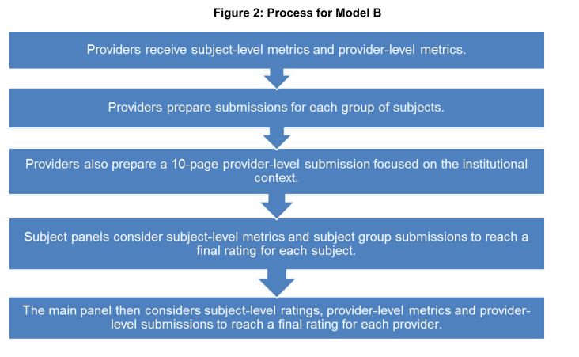

- HEFCE will aim to recruit approximately: 15 providers to participate in Model A, 15 to participate in Model B and 10, if possible, to participate in both models
- Assessment at subject and provider level is determined by pilot panels based on a holistic consideration of metrics and a written submission
- A teaching intensity measure will also be piloted, by collecting data on contact hours, staff-student ratios and class sizes through institutional declarations and a student survey.
- Teacher intensity will be piloted in a small range of subjects in both models, initially including nursing, physics and astronomy, creative arts and design, history and archaeology and law
- Two measures will be piloted for teacher intensity:
- A provider declaration of contact hours they provide, weighted by student-staff ratio (also taking into accounts provisions like placements, fieldwork and e-learning)
- A student survey on number of contact hours, self-directed study and consideration if the contact hours are sufficient to fulfil their learning needs.
- Teaching intensity will be a ‘supplementary metric’ which will be considered with the subject-level submission to inform the holistic judgement.
- After the first year of subject-level pilots the DfE will evaluate both models, including experiences of providers and cost of participation.
- Interdisciplinary degrees will be taken into account through joint programmes and modular degrees
- Later in 2017 there will be a technical consultation document on subject-level TEF to ensure providers, students, employers and other stakeholders have the opportunity to comment on the proposed design.
- The DfE plan to commission research to test aspects of subject-level TEF with a wide group of students.
- They expect that subject-level TEF will be fully implemented in Year 5, with assessments in academic year 2019/20 and subject-level ratings published in Spring 2020.
- DfE has commissioned HEFCE to implement the Year 3 subject-level pilots. When the OfS is established, it is anticipated they will take over implementation of the pilots.
- As at provider-level, each core metric will be presented for a series of sub-groups (called splits) reflecting Widening Participation priorities. These splits will be included in both the provider and subject-level metrics.
- The DfE will aim to have a pool of panellists for the subject-level pilots that is large enough to cover all subjects, but not have different panels for the 35 individual subjects.
- Professor Janice Kay, Provost and Senior Deputy Vice-Chancellor at the University of Exeter and Deputy Chair of the TEF Panel, will chair the main panel for the pilots.
- The same pool of panellists will be used for both models, but will operate differently.
- HEFCE will recruit approx 110 panellists for the pilots:
- Seven subject panels each with approx 12-14 members (matching the 7 subject groups in Model B)
- A main panel of approx 25-30 members, 7 of whom would also act as subject panel chair.
- HEFCE will aim to ensure each of the 7 subject panels has at least one academic members with expertise in each of the 35 CAH2 subjects covered by that group. They will also aim to recruit panellists that have responsibility for teaching across more than one subject group, e.g. Dean level.
- HEFCE will aim to recruit students to make up approx one-third of the panel members
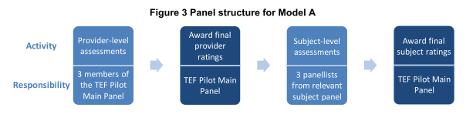

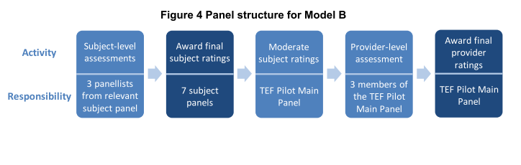

Appendix 